Supplementary Figures

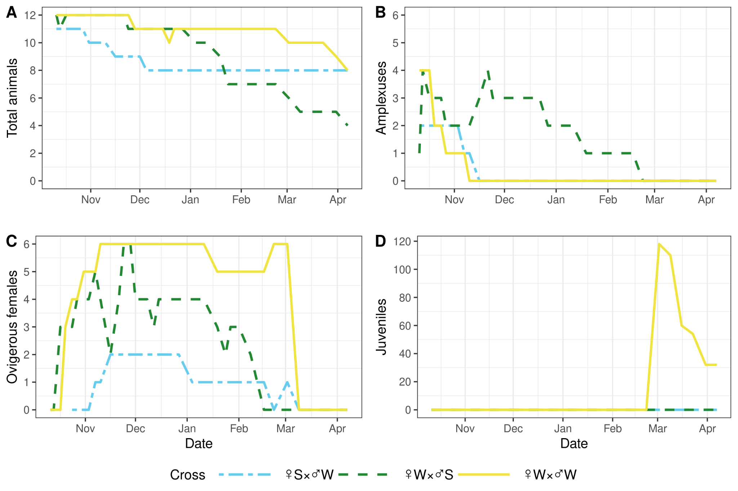
Figure S1. Experimental crossing shows the presence of a postzygotic reproductive barrier between the W and S E. vittatus lineages. Shown are the dynamics of survival (A), amplexus formation (B), number of ovigerous females (C), juveniles (D) in the control cross (WxW) and experimental combinations SxW and WxS.

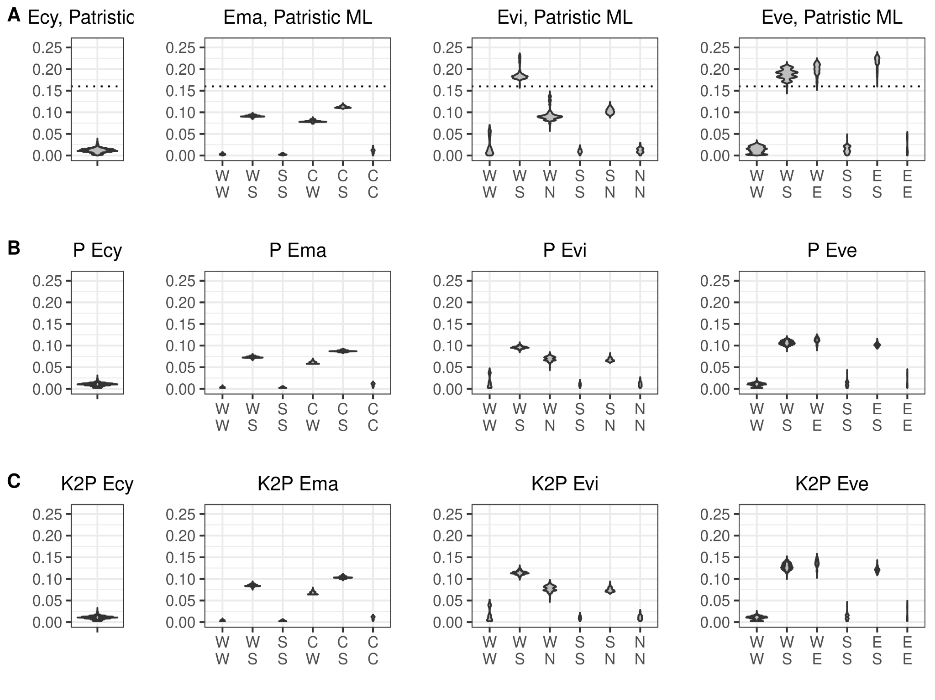
Figure S2. Comparison between uncorrected p (A), K2P (B), and patristic distances for the same set of sequences. Ecy, E. cyaneus. Ema, E. marituji. Evi, E. vittatus. Eve, E. verrucosus.

